TO-DO LIST

Command Line To-Do List:
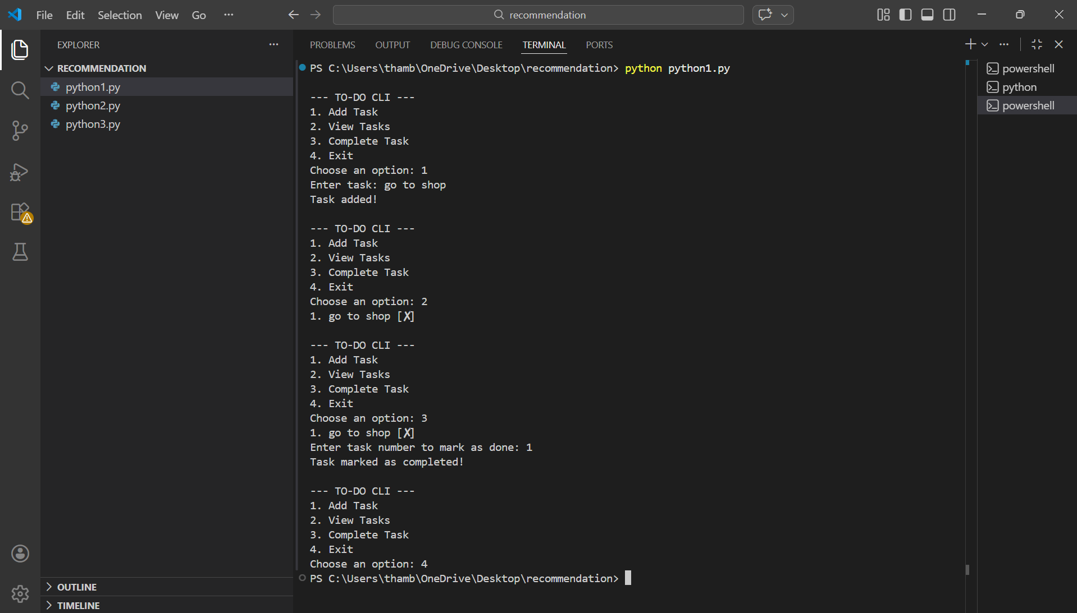
Introduction
In this project, I created a simple To-Do List application using Python.
It runs in the command line and helps users organize their daily tasks easily.
Features
Add Task
The user can enter a new task.
The task is stored in the system and added to the list.
View Tasks
All the added tasks are displayed with a task number.
The status of each task is shown clearly.
Complete Task
The user can select a task number to mark it as completed.
Completed tasks are shown with a special mark like [X].
Exit
This option stops the program safely when the user finishes managing tasks.
Conclusion
This project is a simple task management system that works through the terminal.
It helped me understand how menu-driven programs work in Python.

Smart To-Do Manager (GUI Version)
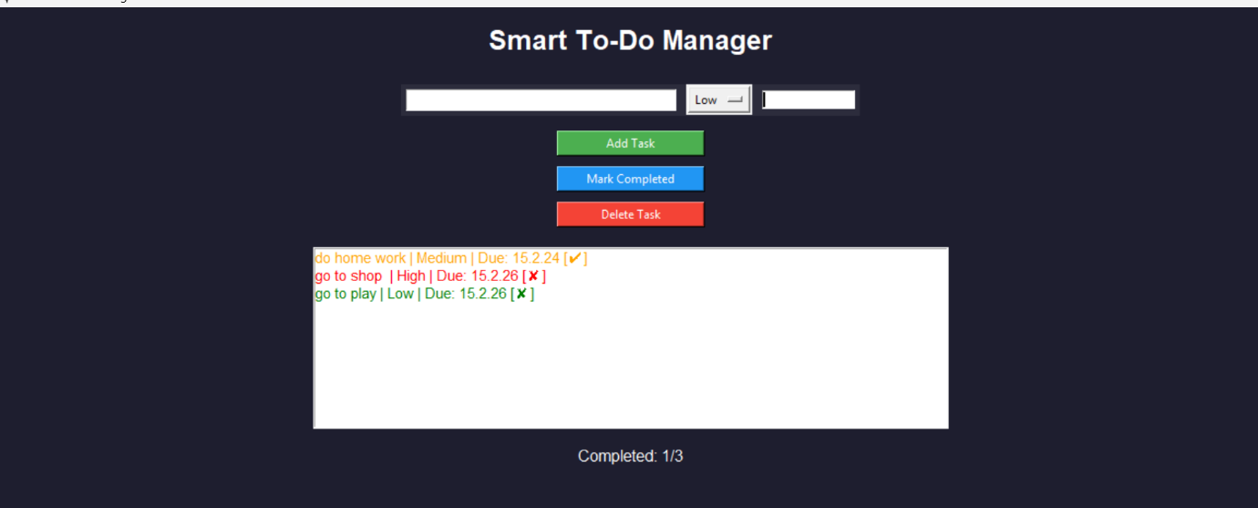
Introduction
This is an advanced version of my To-Do application with a graphical user interface.
It is called Smart To-Do Manager and it allows users to manage tasks more visually and efficiently.

Features
Add Task
The user can enter:
- Task name
- Priority level (Low / Medium / High)
- Due date
After clicking Add Task, the task appears in the task list.

Priority Management
Each task has a priority level:
- 🔴 High (Important tasks)
- 🟠 Medium
- 🟢 Low
Tasks are displayed in different colors based on priority, making it easier to identify important work.

Mark Completed
When a task is finished, the user can click Mark Completed.
Completed tasks show a ✔ symbol.

Delete Task
The user can remove unwanted tasks using the Delete Task button.

Progress Tracking
At the bottom, it shows:
Completed: 1/3
This helps the user track how many tasks are completed out of the total tasks.

Conclusion
This Smart To-Do Manager improves the basic command-line version by adding:
- A user-friendly interface
- Priority levels
- Due dates
- Progress tracking
It makes task management more organized and visually clear.

SMART TO-DO MANAGER (VUI)
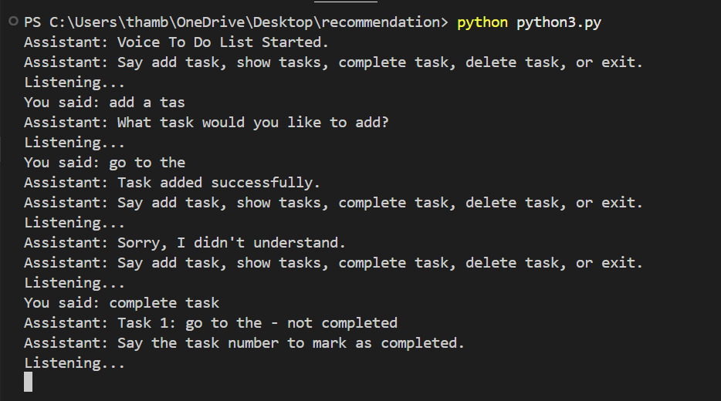
This project is a voice-based To-Do List application where the user interacts with the system using speech instead of typing. The program listens to voice commands such as “add task,” “show tasks,” “complete task,” and “delete task,” and performs the corresponding actions. When the user gives a command, the assistant processes the input and responds with messages like “Task added successfully” or asks for more details if needed. It also handles errors by showing messages like “Sorry, I didn’t understand” when the input is unclear. This makes the application more interactive and user-friendly, allowing hands-free task management compared to the traditional command-line and graphical versions.
Conclusion
This project shows how voice recognition can be used to control applications.
It makes task management more interactive and hands-free compared to CLI and GUI versions.

